Report
of students’ pilot course implementation at Vlora University

supported by Entral Project

Working group

Dr. Enida Pulaj,
Prof. Dr. Roland Zisi,
Dr. Eva Cipi

Title of the course: Innovation Camp

The purpose: The aim of this module is to help students from different disciplines to gain the basic knowledge in entrepreneurship and to bring this knowledge from lectures to practice. The course will help students to gain confidence in self-analysis of entrepreneurship readiness, the role of entrepreneur in economic development, organizational structure, sources of financing, budgeting. Student will further learn to develop their entrepreneurial project in teams.

The objectives of course will cover three key aspects of entrepreneurship:
1) how to start an entrepreneurial project and how to generate business ideas,
2) how to develop business ideas through appropriate business development tools
3) how to bring business ideas to market and how to sell them.

The target groups. The module “Entrepreneurship Camp” is designed for university students. It aims to promote entrepreneurship and innovation among students of different field of study. The students are expected to engage and challenge themselves, as will real entrepreneurs react in similar contexts and especially in the Albanian context. After the camp, participants have a better understanding of the requirements to become an entrepreneur and they can reflect if entrepreneurship can be a possible future career path. The camp also introduces another approach on how to learn about entrepreneurship and foster entrepreneurial skills. Students of different will be better equipped with entrepreneurial skills and open to entrepreneurial mindset,

Implementation of the student course “Innovation Camp”at the University of Vlora
The Innovation Camp was organized by the University "Ismail Qemali" Vlore during May 2–4, 2023 after the pilot course approval by the Rectorate and Academic Senate.
The announcement of the students' module was made available on the official website of the University of Vlora via the following link:
https://univlora.edu.al/2023/04/27/njoftim-per-zhvillimin-e-dy-kurseve-pilot-projekti-entral/
After the publication of the call for participating, the implementation team create the link of registration as below:
https://docs.google.com/forms/d/1aMuZpVSwER4Wx2MwGwrNrOyx_4uf40Lyd6i01tneXYo/edit?usp=sharing_eil_m&ts=6446c0fb&urp=gmail_link
At the end of the registration process, 37 students from the University of Vlora participated in the innovation camp. Most of the students were from the Faculty of Economy and a small part of them were from the Faculty of Technical Science. The focus of the module was to promote entrepreneurship and innovation among students in different fields of study. Through this module, the students learned and gained more practical experience about entrepreneurship and developed new business ideas in teams. Some guest speakers were invited to share their experiences dealing with the challenges faced while opening new businesses. Eight students’ teams were organised to develop the new business ideas and present them on the final day of the training.

All the materials and the activities were very comprehensive for all the participants, and the activities were simple, and all the students participated actively. The students were able to comply with all assignments and tasks given to them and were able to pitch their ideas despite time constraints in three days.

The program of the EntrAL Innovation Camp Program

02 may 2023 - Day 1

9:00 - 9:15 | Welcoming remarks
9:15 - 9:30 | Energizer 1. Introduce each other
9:30 - 10:00 | Supporting lecture Activity 1: Exploring entrepreneurship
10.00 - 10:15 | Self-evaluation. How entrepreneurial are you?
10:15 - 11:15 | Individual self-learning - Exploring Entrepreneurial role models
11:15 - 11:30 | Break
11:30 - 12:00 | Guest Speaker Shkelqim Sinanaj, Entrepreneur in Tourism sector, Vlore
12:00 - 14:00 | Facilitated Team Work Activity 2: Team Building
14:00 - 15:00 | Lunch break
15:00 - 16:30 | Supporting lecture Activity 3: Generation of a business idea
16:30 - 19:00 | Facilitated team work session Activity 3: Brainstorming in teams

03 May 2023 - Day 2

9:00 - 10:00 | Supporting lecture Activity 4: Business Development Tools and Methods
10:00 - 12:00 | Facilitated team work session Activity 4: Business environment analysis Start Ups
12:00 - 12:30 | Guest Speaker Anjeza Shiko, Director of Local Tax, Municipality of Vlora
12:30 - 14:00 | Facilitated team work session Activity 5: Identifying the key components of a business plan
14:00 - 15:00 | Lunch Break
15:00 - 16:00 | Supporting lecture Activity 6: Business Canvas Model
16:00 - 17:00 | Exploring Strategyzer Platform
17:00 – 17:15 | Break
17:15 - 19:00 | Facilitated team work session Activity 6: Identifying key components of the business development plan in teams

04 May 2023 - Day 3

9:00 - 10:00 | Pitching and simulations
10:00 - 11:00 | Lessons learned from the module
11:00 - 13:00 | Presentations
13:00 - 14:00 | Lunch break
14:00 - 15:30 | Presentations
15:30 - 16:00 | Award ceremony and distribution of the certificates to the participants. Final remarks.

The methodology
The module offers a range of activities that integrate theoretical concepts with practical application. These activities aim to develop the final business plan and video pitch for the entrepreneurial project. The utilization of participatory methods and other techniques was crucial in enabling the participants to gain a clear understanding of the learning content. Several techniques, tools and teaching aids were used to support entrepreneurial learning, including:
- Warming up/energizer
- Brainstorming
Self-reflection and team building exercise
- Group discussion
- Lectures and case studies
- Video
- Analytical questions
- Invited guest
- Pitching role playing simulation
- Group work (onsite)
- Guest speaker
- Facilitated group work
- Pitching role playing simulation
- Final simulation presentations

Students’business ideas:
1. EduAL- Education app for children in Albanian language
2. Next door - a virtual market place for electricians, plumbers, pet care services, etc
3. DUA - an entertainment centre for children with disabilities
4. My step - Services for aged and sick people that need to be taken care of at home
5. BIO Tour guide- Touristic guide offered to foreign and domestic tourists from some biologist students
6. Toska art – an artisanal shop with handmade works of dried flowers and embroidery
7. ECO Tourism- offering accommodation in eco-friendly houses
8. “Sweet shop” in Lungomare

Pilot course evaluation

The email addresses have been sent to the project coordinators for an individual evaluation by the students who participate in the course.
In the survey 14 students participated because of a late distribution of survey. The average of age was 22.6 years old. There was a mis distinguishing of course title. Only 54 % selected the right one and 100% of them selected the own university.
About the course content and organization, the evaluation score in average was 4.3/5 . For 64% The learning outcomes of the course were clear and for 57% the course workload was manageable. 64% strongly agree with definition: a course well organized.
About the student involvement in the course, the students agree and strongly agree respectively 43% and 50 % about the active commitment during the course and the making a progress during the course. At the end, they felt in general appreciated as students during the course.
About Learning environment and teaching methods, 36% and 57 % of students respectively agree and strongly agree that the overall environment in the class was conducive to learning. The Learning resources was appreciated as useful by 57% as strongly agree and 36% as agree with this definition. The same evaluation was for the reading books. The quality of delivery was appreciated the axes of interest, presentation of ideas and concepts by more than 80% of the participants. The expectations on entrepreneurial thinking reinforcement, reaching the general goals and supporting personal development for the future were strongly appreciated by more than 57% of the participants and other agree with these achievements.
About the question what or which factors were the best in the course? The students’ comments show that they appreciate the course on
- Organization of knowledge and the way it was conveyed to students
- The cooperation that the students had with each other
- The cooperation that the students had with each other.
- Together with the relationship with the individual, the other members of the group, the new information they received and the help it gave them for my future
- The best factors were the environment and teaching methods. The trainers helped me to fully understand the issues that were studied during the course, strengthening my entrepreneurial thoughts. I think that the course was structured well enough to achieve the best results by mixing lectures and practice.
- The clear explanation. Interaction with students.
- New knowledge.
Regarding the improvements there are some recommendations like:
- There should have been more concrete and clear examples for all students of the course.
- There should have been more concrete examples
- Students should be given more opportunities to practice their knowledge in this field.

Conclusions and problems

- High interest of students for thematics
- Good engagement of students in group activities
- Active discussions and participation of students in some specific issues related to the business idea generation
- Low level of knowledge for `teaching programs students
- The lack of working in groups

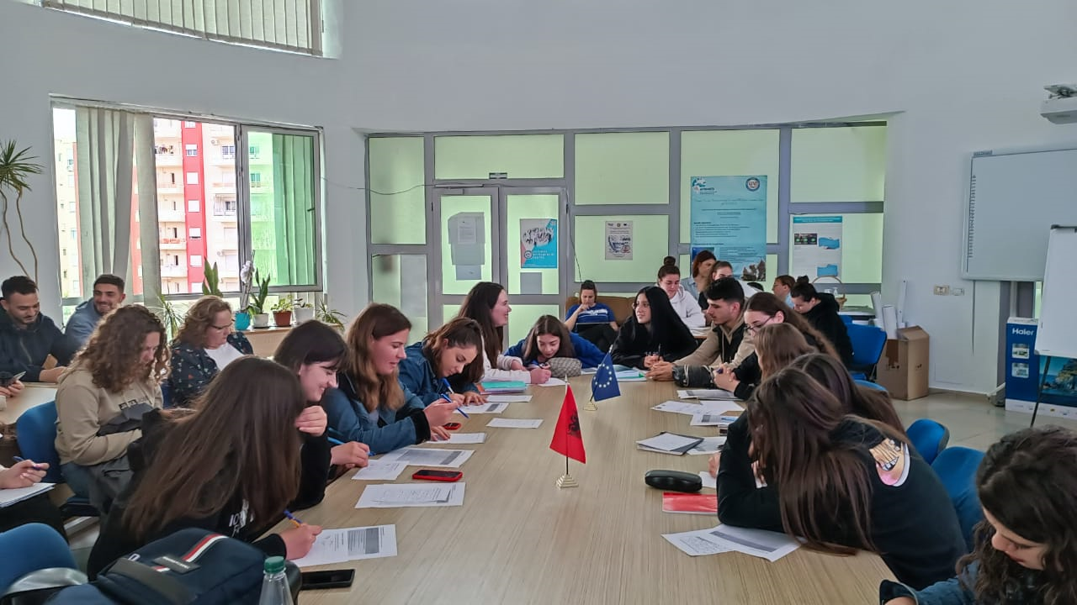

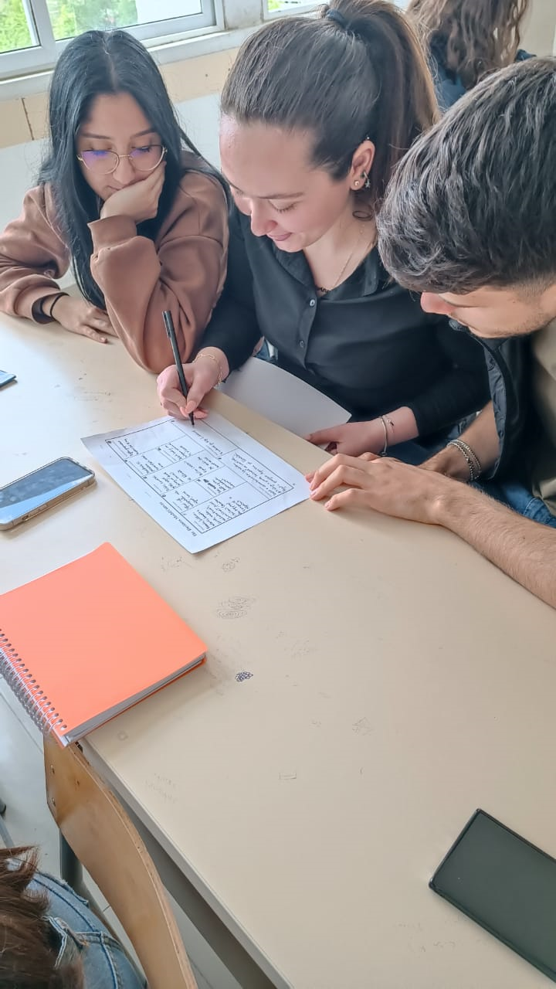 | 