REPORT

ON THE IMPLEMENTATION OF THE PILOT COURSE FOR THE ACADEMIC STAFF

TOWARDS AN ENTREPRENEURIAL MINDSET

Developed as part of the Entral project

Work group
Andi Spahi
Blerina Mema
Safiola Carcani
Roland Palushi (Lektor i ftuar)

Module topic: Towards an entrepreneurial mindset

Purpose of the module:
The purpose of this module is to increase the awareness of the academic staff with information and practices from entrepreneurship at the academic levels and to increase the interest and awareness that the staff should have during lectures or seminars in Albanian HEIs.

Module Objectives
Implementation of entrepreneurial ideas in the university environment by encouraging the entrepreneurial behavior/mindset of academic staff, entrepreneurial teaching methods, and supporting the creation of new ventures.

Target group.
In general, lecturers/academic staff have an essential role in promoting entrepreneurial knowledge and skills among students. They should help students learn how to identify, develop and manage business opportunities and contribute to the growth of the entrepreneurial culture in society.
Educators should offer courses that introduce students to the fundamental concepts of entrepreneurship, including idea development, business planning, resource management, finance, marketing, and risk management.

During this training, it was intended that the academic staff use case studies to introduce students to the real challenges and situations they may face in the business world. This type of learning gives students a hands-on experience. Also, academic staff should be mentors to students interested in entrepreneurship. They can help students develop their ideas, create business plans, and share contacts with other entrepreneurs and business professionals.
A key point during this training was the introduction of ideas on the organization of entrepreneurial competitions and research projects, which is an excellent way to encourage students to develop and present their projects.
Educators can use technology and online resources to provide learning materials, relevant information, and connections to entrepreneurs and entrepreneurial organizations. Explore business opportunities and contribute to the growth of an entrepreneurial culture in society.

Implementation of the module among the academic staff

On May 26-29, 2023, the University of Sports of Tirana, within the framework of the implementation of the pilot module Towards an entrepreneurial mindset of the 🇪🇺Project ERASMUS+ CBHE #ENTRAL, successfully completed the training with the academic staff of the university. This training module was carried out by invited trainers and entrepreneurs.

At the end of the registration process, the innovation camp was attended by 21 academic staff from the University of Sports in Tirana from the three constituent faculties of this University such as: Faculty of Movement Sciences, Faculty of Physical Activity and Recreation and Faculty of Rehabilitation.

During this module, a very successful entrepreneur was also invited, who shared with his colleagues his experience since its beginning.

The methodology used
During this module, teaching methods and tools are used such as Brainstorming, Power Point Presentation and audio visual material from the guest lecturer as well as discussions/debates as well as group work during the development of the module.

Course evaluation

The email addresses were sent to the project coordinators for an individual evaluation by the participating academic staff and the results are as follows. 21 academic staff participated in the training, of which 14 responded to the survey.

Overall evaluation of the Pilot Course
Overall score 6.1

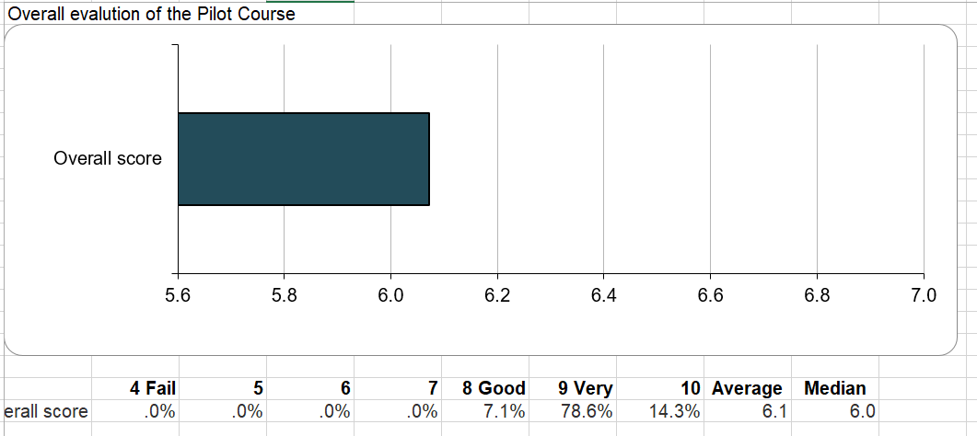

Further comments or suggestions

What or which factors in the course require improvement?
Responses
_
The motivation to lead the students towards this thought.
ANY
I have no request.
Less theory and more practice
Nothing
I have no comment
I have no comment

Conclusions and ideas that require improvement

In this module, there was a very high interest from the academic staff, as well as the discussion and active participation throughout the module was at a high level. Some suggestions:

1. Universities can offer special entrepreneurship research courses that train students in the areas of idea development, project management, finance, marketing, and risk management.
2. Universities can offer degree programs, graduate programs and entrepreneurship programs for students who are interested in developing a career in business management and entrepreneurship.
3. Entrepreneurship training in universities is important to prepare young people for the challenges of business development, as well as to contribute to economic growth and innovation. These programs must be adapted to market needs and encourage students to create new value for society and the economy.
4. Academic staff should encourage a culture of entrepreneurship in their university, creating dedicated spaces for research and development, organizing entrepreneurial activities and promoting entrepreneurial values across the campus.

View from the module implementation

