Report
Implementation of pilot course “Innovation Camp” of the EntrAL project
at the University “Aleksandër Moisiu” Durrës

Dr. Alketa DUMANI
Prof.Dr.Kseanela SOTIROFSKI
Dr.Olta NEXHIPI
Dr.Oliana SULA
MSc. Besiana ELEZI

Durrës, 2023

1. Title, purpose, objectives, target group
1.1 Title
Innovation camp
1.2 Purpose
The main purpose of this module was to make students who participated in this module experience the concept of Innovation Camp through generating, developing and selling their business idea in teams replicating the Innovation Camp model of the UTU Innovation Camp held in November 2021.
1.3 Objectives
- Better understanding on the requirements of how to be an entrepreneur
- Development of entrepreneurial skills
- Development of the entrepreneurial mindset for university students
1.2.4 Target group
The target group of this module were students of the University “Aleksandër Moisiu” Durrës. The main aim was to incentivize the participation of students from disciplines that were not traditionally linked to entrepreneurship.
2 .The call
The official call was distributed via the official website of the university and its social media channels for a duration of one month. The selection of the students was made by the EntrAL project team based, one of the main criteria of selection was the students’ motivation.
3. Methodology
- Energizers
- Lectures
- Case studies
- Ice-breakers
- Team building activities
- Self-reflection activities
- Strategizer platform
- Simulations.
4.Number of participants and days
48 participants, 12/12/2021 (Info day), 13/12/2021-15/12/2021(Innovation Camp)
4.1 Participants
The Innovation Camp had 33 % of the students were at their first of the studies of the bachelor degree, 53% at their second year of the studies of the bachelor degree and 14 % from the first year of the studies.
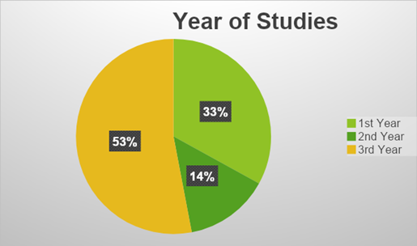
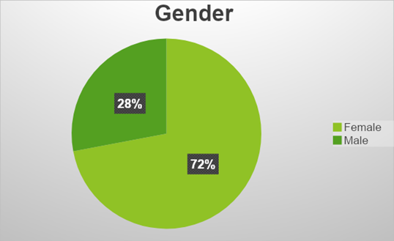
The majority of the participants were females.
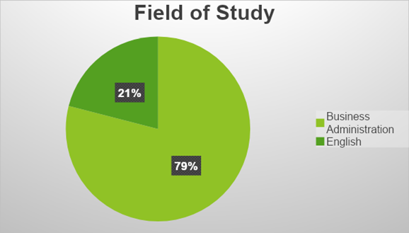
The majority of participants were students in the Bachelor program “Business Administration”.
4.2 Days
Day 1
9:00– 9:15 Welcoming remarks
9:15 – 9:30 Energizer: Find the leader
9:30-9:45 Energizer 2
9:45 – 11:00 Supporting lecture Activity 1: Exploring entrepreneurship
11:00 – 12:00 Individual self-learning –Exploring Entrepreneurial role models
12:00 – 13:00 Lunch break
13:00 – 14:00 Guest Speaker Pranvera Rrapushi: Women Entrepreneurship Environment in Albania
14:00 – 17:00 Facilitated Team Work Activity 2: Team Building
17:00-18:30 Supporting lecture Activity 3: Generation of a business idea
18:30-21:00 Facilitated team work session Activity 3: Brainstorming in teams
Day 2 December 14
9:00 – 10:00 Supporting lecture
Activity 4: Business Development Tools and Methods
10:00-12:00 Facilitated team work session Activity 4: Business environment analysis Start Ups
12:00-13:00 Lunch break
13:00-14:00 : Supporting lecture Activity 5: Business Development Tools and Methods
14:00-15:00 Guest Speaker Armand Hasko
15:00: 17:00 Facilitated team work session Activity 5: Identifying the key components of a business plan
17:00-18:00 Supporting lecture Activity 6: Business Canvas Model
18:00-19:00 Exploring Strategyzer Platform
19:00-21:00 Facilitated team work session Activity 6: Identifying key components of the business development plan in teams
Day 3 December 15
9:00- 10:00 Pitching and simulations
10:00-11:00 Lessons learned from the module
11:00-12:00 Presentations
12:00-13:00 Lunch break
13:00-14:30 Presentations
14:00-15:00 Award ceremony and distribution of the certificates to the participants. Final remarks
5. Preamble
Innovation Camp contained 3 sessions: Starting a business project, building and business project and selling a business projects. Sessions were divided in 7 activities: introduction to entrepreneurship, entrepreneurial skills, generating business ideas, analyzing business environment, business plan, business model canvas and pitching.
The aim of the first session was explain to students how to start an entrepreneurial project focusing on exploring the main the key concepts of entrepreneurship, developing entrepreneurial skills and generation of a business idea. The second session focused on building an entrepreneurial project, students performed market analysis through PESTLE and SWOT, they learned on how to develop a business plan and they used Business Model Canva. In the last session students presented their business idea in front of a jury using the elevator pitch method.
6.Evaluation
The evaluation was made as it follows:
Session 1 assessment : 35 %
Session 2 assessment : 45 %
Session 3 assessment : 20%
Total : 100%
Students presented their final business ideas on Day 3. A jury composed from the lectures of the Faculty of Business at the University “Aleksandër Moisiu” Durrës and the business sector. Students were awarded with certificates of participants and credits.

